Eur-Bulgaria-Lamp-three wick-Roman

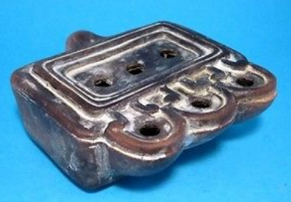

**Replica of a Terracotta Oil Lamp with very rare triple wick design .The Original  was found in the ruins of the ancient Roman town AUGUSTA TRAJANA( present days STARA ZAGORA, BULGARIA).** **And at the moment it is for a display in the Archaeological Museum in Stara Zagora.**

**The Replica is made of ceramic material and hand painted with special lack and varnish to imitate an old patina of the clay. It is marked on the bottom. This is a perfect artefact for your home interior or precious gift for every occasion.**

**Size:88/84/34 mm;  Weight-126g;**